|  |  |  |
| --- | --- | --- |
| ***Lesson*** | ***Objectives*** | ***Material*** |
| Intro | Introduction to course | Course documents |
| 1.1 | Introduction to Quantitative Reasoning | Introduction to Quantitative Reasoning |
| 1.2 | Dimensional Analysis | Cost of Power |
| 1.3 | Scientific notation & Engineering Notation | Engineering Notation |
| 1.4 | Fractions and Ratios | Transformers |

**Prerequisite Assumptions**

Before beginning the lesson, students should be able to;

* Multiply two fractions
* Divide two fractions
* Simplify fractions by ’canceling’ or dividing common factors in the numerator and denominator
* Multiply fractions by 1 to create a common denominator.

The following is Adapted from © 2014 THE CARNEGIE FOUNDATION FOR THE ADVANCEMENT OF TEACHING

Quantitative reasoning: You might be surprised that you are asked to write short responses to questions. This course emphasizes writing for the following two reasons:

* Writing is a learning tool. Explaining things such as the meaning of data, how you calculated the data, or how you know your answer is correct deepens your own understanding of the material.
* Writing is a means of communication. Products in today’s world, such as reports, news articles, publicity materials, advertising, and grant applications, contain quantitative information. Being able to communicate quantitatively is an important literary skill.

Understanding the task: One important strategy is to make sure you understand the task. In this course, your tasks will be answering questions in the assignments, but in other life situations the task might be answering a question on a report form, following instructions from your employer, or working towards a goal that you set for yourself. To begin to write successfully, ask yourself the following questions:

* What is the question / task?
* What is the task telling me to do? Some examples are given below:
  + Reflect and describe on the process of coming up with the answer.
  + Make a prediction
  + Compare two data points or the answers to two parts of the problem
* What information do I have to help me with the task?
* What is the likely relationship between my task and the information I have?

Does the information make sense? During this course, you will be presented with a number of problem situations. These problem situations will help you learn how to evaluate the types of quantitative information you may encounter in everyday life.

For example, math is used every time you decide which cable package to sign up for, when you get a medical bill, and when you look at interest on your credit cards. Marketers use math sometimes to make a product seem better or more widely used than it actually is — how can you make good decisions and save money if you can’t tell when they’re being sneaky? Math also gets used in politics all the time. On TV they report surveys that, for instance, say 80% of people approve of something – but 80% of which people? These types of everyday math problems don’t require complicated math – it’s mostly addition, subtraction, division, etc. But they do require complex thinking. This course is about the use of straightforward math to do complex thinking

When presented with a problem situation you should;

* Write down the question / task.
  + Reflect and write the process of coming up with the answer. You may also make a prediction at this point to develop an insight into the problem.
* Write down the information you are given.
* Solve the problem.

**Specific Objectives**

*By the end of this lesson, you should understand;*

* Quantitative reasoning is the ability to understand and use quantitative information. It is a powerful tool in making sense of the world.
* Relatively simple math can help make sense of complex situations.
* 1,000,000,000, 109, and 1G have the same meaning
* Engineering notation

*By the end of this lesson, you should be able to;*

* identify quantitative information
* convert engineering notation to and from different notations (e.g. ordinary and scientific notation)
* understand how to work with fractions and ratios
* understand how to calculate percentage increases and decreases
* work in groups and participate in meaningful discussions
* understand how to properly use a calculator
* solve expressions using the order of operations, commutative laws, distributive laws, associative laws, exponent laws, scientific notation, and engineering notation

# Problem Situation 1.1 – Introduction to Quantitative Reasoning1

Imagine that you just received a flier in the mail with the following statement:2

1. What are some social issues or political ideas that this statement might support?
2. Do you think the statement “Every year since 1970, the number of children gunned down has doubled,” is a reasonable statement? Discuss with your group.

The flier in “Problem Situation 1.1” includes quantitative information. Quantitative information uses concepts about quantity or number (this can be specific numbers, or a pattern based on numerical relationships such as doubling).

You hear and see statements that include quantitative information every day. People use these statements as evidence to convince you to do things like

* vote a certain way;
* donate or give money to a cause; or
* understand a health risk.

You often do not know whether these statements are true. You may not be able to locate the information that supports these statements, but you can start by asking if the statements are reasonable. This means asking if the statements make sense.

Using only the information that was included in the flier, how can you decide if the statement was reasonable? Talk with your group about the different ways in which you might answer this question.

1. In the previous question, you thought about how to decide if the statement was reasonable. One approach is to start with a number for the first year.
   1. Start with “1” and fill in the following table.
   2. Complete the other values in the second column of the table.
   3. Round the number to three significant digits in the third column.

|  |  |  |
| --- | --- | --- |
| **Year** | **Number of children gunned down** | **Rounded to 3 significant digits** |
| 1970 | 1 |  |
| 1975 |  |  |
| 1980 |  |  |
| 1985 |  |  |
| 1990 |  |  |
| 2000 |  |  |
| 2010 |  |  |
| 2017 |  |  |

1. Refer to the table you created in the previous question. Does the number of children gunned down in the year 2017 seem reasonable?

1Adapted from © 2014 THE CARNEGIE FOUNDATION FOR THE ADVANCEMENT OF TEACHING

2Adapted from Joel Best, Damned Lies and Statistics: Untangling Numbers from the Media, Politicians, and Activists (Berkeley: University of California Press, 2001).

# Problem Situation 1.2 - Cost of power – *Dimensional analysis, percentages, units*

A watt, named after James Watt, is a unit of power and is defined as the *rate* of energy transfer (or work). An electronic device, such as a refrigerator, microwave, motor or hair dryer converts electrical energy into mechanical energy or heat. The watt is the rate energy is used. A watt is one joule per one second, the symbol J/s. A kilo Watt (kW) is 1000 Watts. Your electric bill is based on the power consumed in kilo Watt hours (kWh). 1kWh = 1000 Watts consumed in 1 hour = 500 Watts consumed in 2 hours

Madison Gas and Electric (MGE) has a seasonal rate structure with summer rates charged from June 1 through September 30 and the winter rate applies the remainder of the year.

|  |  |
| --- | --- |
| **Per kWh Rate** | |
| ***Summer – 6/1-9/30 (122 days)*** | ***Winter – 10/1-5/31(243 days)*** |
| $0.141630 | $0.130250 |

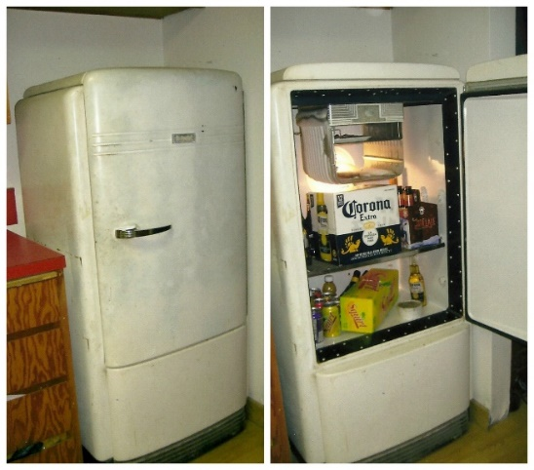

1. This old refrigerator still runs and keeps the contents mostly cold. How much to you think this fine appliance would cost to operate annually for an average family (Prediction)?
2. What information would you need to determine the actual impact of this appliance on the electric bill?
3. How many hours a day does the compressor run?
4. How many kWh are consumed daily?
5. What is the cost to operate this refrigerator in the summer?
6. What is the cost to operate this refrigerator in the winter?
7. What is the total annual cost of operation?
8. Would you recommend replacing this refrigerator? What criteria would you use to make the recommendation?
9. One sound method for this type of decision-making is the rate of return, gain or loss on an investment. Discuss with your group how you would determine the rate of annual savings. What information do you need?

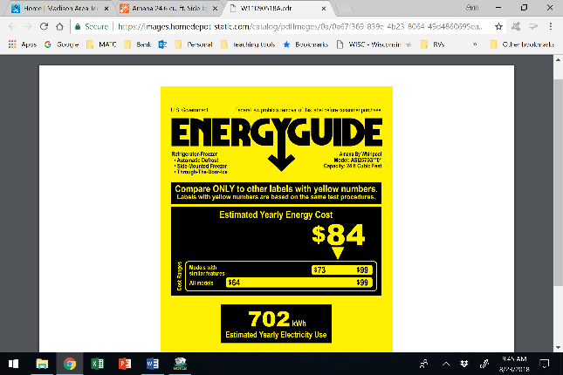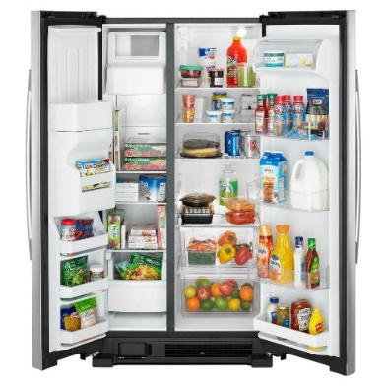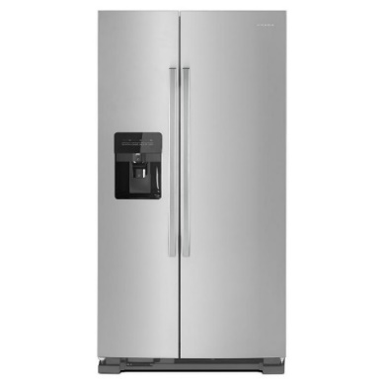

1. This Amana 24.6 cu. ft. Side by Side Refrigerator with Dual Pad External Ice and Water Dispenser in Stainless Steel has gotten good reviews, and it fits the same space. It is on sale for $897.30, *not* including 5.6% sales tax. With purchase, there is an additional $20 delivery charge, but disposal of the old unit is included. What is the total cost of the purchase?
2. Assuming the energy rating is accurate; determine the annual savings, the annual percent savings and the amount of time to recover all of the investment.
3. Would you now recommend replacement of the old refrigerator?
4. Now that you know how to make data driven decisions for appliances, you are thinking of upgrading your old 20-Watt TV. You want to purchase a 50” plasma TV that consumes about 300 Watts of energy. Your family loves to watch movies together especially in the cold winter months so the TV is typically on about 4 hours a day. What is the actual cost of operating each TV at $0.130250/kWh? What is the percentage increase in energy consumption for the new 50” plasma TV over a 30-day month?





# Problem Situation 1.3 Talking Engineering – *Engineering notation*

Engineering notation is used quite a bit, especially in the electronic industry. It is a form of writing and talking about really big and really small numbers easily. It is a version of scientific notation in which the exponent of ten must be divisible by three and the number left of the decimal point must be between 1 and 999 inclusive. Additionally, we also use a metric prefix name and corresponding symbol, to abbreviate the number even further.



1. We are surrounded by digital information from digital pictures, files, music, movies, etc. These bits of data are stored in hard drives, servers and in the cloud all across the world. Digital information is stored in bits and each bit is either a zero or a one. A bit, which is the smallest unit of storage, contains information that is defined by two separate states: one or zero, often considered on or off. EXAMPLE: A car door is closed / open $↔$ 1 / 0.

There are 8 bits in a group called a byte. A letter in a text message requires a byte of storage space. If your message is 19 characters, it takes 19 bytes to store.

In 1975 a 5.25” floppy disk had a whopping capacity of 110 kilobytes. WOW! By the mid 1980’s a single compact disc, CD, could hold 550 megabytes. In 2009 the first terabyte hard drive was introduced.

Given the following digital information, determine the number of bits and bytes.

|  |  |  |
| --- | --- | --- |
| **Device** | **# bytes** | **# bits** |
| 110 kilobyte (KB) disk |  |  |
| 324-character text message |  |  |
| 2.5 Terabyte (TB) hard drive |  |  |
| 4 Gigabyte (GB) memory |  |  |

1. There are 2 values that can be represented with 1 bit, it can either be 0 or 1. The number of values represented doubles for every additional bit. 2 bits can be 00, 01, 10, 11 thus, there are 4 potential configurations for 2 bits. Mathematically: *n* bits = 2*n* potential values. Determine the missing information in the table below for the number of potential configurations.

|  |  |  |  |  |  |  |  |  |  |  |
| --- | --- | --- | --- | --- | --- | --- | --- | --- | --- | --- |
| **Bits** | **2*n*** |  | **Potential configurations** | | | | | | | |
| 1 bit | 21 | 2 | 0 | 1 |  | | | | | |
| 2 bits | 22 | 4 | 00 | 01 | 10 | 11 |  | | | |
| 3 bits | 23 | 8 | 000 | 001 | 010 | 011 | 100 | 101 | 110 | 111 |
| 4 bits | 24 |  |  | | | | | | | |
| 5 bits | 25 |  |
| 6 bits |  |  |
| 7 bits |  |  |
| 8 bits |  |  |
| 16 bits |  |  |
| 32 bits |  |  |

1. ASCII is an encoding system used to represent each type character by a number that can be stored in 1 byte. Example: A is 01000001, B is 01000010, a is 01100000 and space is 00010000. Determine how many bytes will be required to type in the message:

***“An opinion without 3.14 is an onion.”***

1. We live in an analog world with all things in nature being continuous variable (always connected and changing) physical quantities. The wind, a swing, music, etc. are all analog systems. Computers and computing systems are digital; therefore, the analog information must be converted to digital information. The best example of this is a typical clock; analog clocks have hands that are in motion constantly while a digital clock only counts (or samples) the time in 1 second increments.

.

The frequency that sampling occurs is called the sampling rate and is given in samples per second with a unit of Hertz (Hz). The sampling rate of 60 Hz is 60 samples per second, and the sampling rate of a 55 Kilohertz (KHz) is 55,000 samples per second.

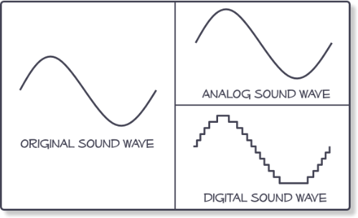Notice in the figure on the right that the analog sound wave is identical to the original sound wave, however the digital sound wave is stepped. Larger sampling rates, more samples per second, shorten each step and the wave becomes more and more like the original sound wave. If you were to sample your favorite analog song only once every second you would get a much-distorted group of sounds. As the sampling rate is increased the wave distortion decreases, and the sound quality improves.

Given the following table determine the missing information. The top row is an example.

|  |  |  |  |
| --- | --- | --- | --- |
| **Period**  Sec between samples | **Period**  Engineering notation | **Frequency**  Hz  (samples/sec) | **Frequency** Engineering Notation |
| 0.000133 sec | 133 μ sec | 7500 Hz | 7.5 kHz |
|  |  | 60 Hz |  |
|  |  |  | 6.5 kHz |
|  |  | 12,000 Hz |  |
| 83.3 sec |  |  |  |
|  |  |  | 920 MHz |

# Problem Situation 1.4 Transformers – *Fractions and Ratios*

Transformers are electrical components used to increase voltage or decrease voltage. A transformer basically is very simple electro-magnetic passive device that works on the principle of Faraday’s law. Mutual induction is the process by which a coil of wire magnetically induces a voltage in a secondary coil located near it. Then we can say that transformers work in the “magnetic domain”, and transformers get their name from the fact that they “transform” one voltage and current level into another.

The number of wraps of wire on each side determines how much the voltage is increased or decreased. The *primary* coil is the one that has the applied voltage and the *secondary* coil is the coil with the changed voltage.

The primary side is represented with a subscript of P for primary,

* IP is the current on the primary side,
* VP is the voltage on the primary side,
* NP is the number of turns of wire on primary coil.

The secondary side is represented with a subscript of S for secondary,

* IS the current on the primary side,
* VS is the voltage on the primary side
* 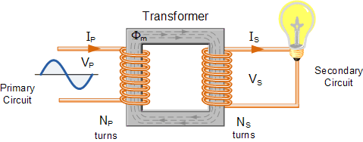NS is the number of turns of wire on primary coil.

The turns ratio, *n* = $\frac{N_{P}}{N_{S}}$ is an important characteristic of a transformer.

The turns ratio may be reduced to a decimal number and is also represented as *NP:NS*.

1. A voltage transformer has 2500 turns of wire on its primary coil and 500 turns of wire for its secondary coil. What is the turns ratio (*n*) of the transformer?
2. Below is a formula that is used to design or analyze any transformer voltage.

$$\frac{N_{P}}{N_{S}}=\frac{V_{P}}{V_{S}}$$

Given that the input voltage, VP is 120 V, NP is 3200 and NS is 400. Determine the secondary voltage, VS.

1. Another method for determining a solution when working with ratios is to cross-multiply the two ratios.

$$\frac{N_{P}}{N_{S}}=\frac{V_{P}}{V_{S}}{ {→N}_{P}V_{S}=V}_{P}N_{S}$$

Determine the turns on the secondary (NS) given that VP = 120 V, VS = 5 V and NP = 480 turns.

Determine the transformer turns ratio (*n)*.

This is referred to as a step-down transformer because the voltage is *stepped down* from the primary side to the secondary side, 120 volts to 5 volts.

1. You are to specify a *step-up* transformer, which is where the secondary voltage is higher than the primary voltage. The primary voltage is 300 Volts, the secondary voltage needs to be 6,000 Volts and the secondary side of the transformer has 12,000 windings. Determine the required turns ratio (*n*) and the number of windings (NP) on the primary side.
2. You need to specify a transformer that will run a small heater which requires a secondary voltage, VS = 24 V and a primary voltage, VP = 120 V. Determine the turns ratio (*n*) for this transformer.