|  |  |  |
| --- | --- | --- |
| ***Lesson*** | ***Objectives*** | ***Material*** |
| 2.1 | Introduction to circuits | Modeling Circuits |
| 2.2 | Series voltage sources | Flashlight batteries |
| 2.3 | Parallel voltage sources | Door Lock batteries |
| 2.4 | Ohm’s Law | Ohm’s Law |
| 2.5 | Linear Equations | Popcorn |
| 2.6 | Power Rule and Ohm’s Wheel | Power Rule |

**Prerequisite Assumptions**

Before beginning the lesson, students should understand

* how to operate their calculator,
* dimensional analysis,
* percentages,
* ratios and fractions and
* engineering notation.

**Specific Objectives**

*By the end of this lesson, you should understand;*

* Simple electrical circuits using a source, resistance (load) and circuit path
* Voltage sources in series and in parallel
* Circuit analysis using Ohm’s Law
* Circuit analysis using the Power Rule

*By the end of this lesson, you should be able to;*

* Apply Ohm’s Law to analyze simple circuits
* Manipulate linear equations that represent circuits
* Solve linear equations to understand circuit behavior
* Calculate series and parallel voltages across components in circuits

**Modeling notes:**

We model circuits in a schematic, which is simply a sketch of the circuit. Think of a schematic as a “recipe” for building the circuit.

A circuit must have;

* A **source**, most often a **voltage source** that pushes the electrons along. Think of the voltage source as the pump that forces water (current) through a pipe. The unit for Voltage is *volts (V)* and the unit for current is *amperes* or *amps (A)*. Throughout this program, you will use conventional flow of current, which means that the current is always pushed out the positive terminal of the voltage source and into the positive terminal of devices. It is important that the direction of the current flow be indicated on your schematic.
  + On a schematic, voltage is represented with these symbols
* The **load** consumes power and impedes or resists the flow of electrons. To function, a load will need voltage and current. The unit for a resistance is *Ohms (Ω)*.
  + On a schematic, the following symbols are frequently used.



* **Ground** is most often used as a reference voltage and is always at zero voltage (0 V) or zero potential. Ground (or some other reference) is required for a circuit to operate. When the ground symbol is not explicitly shown on a schematic, assume that it is on the negative side of the voltage source.
  + On a schematic, the ground is represented with the following symbol
* A **closed conductive path** connected from the voltage source through the load to ground. This path depicts the conductive wire that connects all the components within the circuit.
  + Represented with a line (or lines) on a schematic

The figure to the right is a schematic of a simple electronic circuit. This circuit consists of

Current

* a battery voltage source which pushes the current along
* an arrow that indicates the direction of the current, note that conventional flow of current leaves the source from the positive terminal and enters components at the positive terminal.
* a switch to complete the electrical path
* a load, which provides resistance to the current, consumes energy, and produces work. So if the load is a light bulb, the light will illuminate when the flow of electrons starts.
* a ground, which is required for a circuit to operate.

The natural physical laws are responsible for the responses within the circuit and we use simple mathematics to predict how the circuit will behave.

***Battery***

Batteries are a common source of power. In a battery, a chemical reaction causes electrons to flow.

Battery ratings include the **capacity** in *amp-hours (amp-hour* or *A-hr)*. A battery rated at 1 amp-hour should be able to supply a current of 1 amp to a load for exactly 1 hour, or 2 amps for 1/2 hour, or 1/3 amp for 3 hours, etc., before becoming completely discharged. In an **ideal battery**, current and voltage are stable forever. Often engineers use ideal components like a battery to do analysis and simulation.

The following chart from Duracell shows some typical characteristics of their batteries.

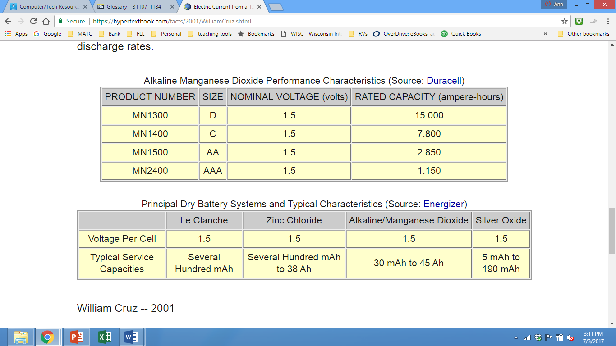

As shown above, AA, AAA, C, and D batteries, each produce1.5V but have different capacities.

Batteries strung together in **series** increases the *voltage*. Batteries strung together in **parallel** increases the *current*.

The *voltages* of batteries connected in series *increase*. Batteries in series have the positive terminal connected to the negative terminal of the next battery. This configuration is called **series aiding**.

Four 1.5V AA batteries placed in **series** give a total voltage of,

1.5V + 1.5V +1.5V +1.5V = 6 volts.

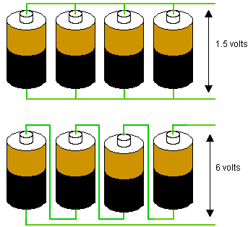

[https://forum.sparkfun.com/viewtopic.php 1https://forum.sparkfun.com/viewtopic.php?f=14&t=35921](https://forum.sparkfun.com/viewtopic.php?f=14&t=35921)

*What would be the expected maximum current out of this circuit?*

The *current* of batteries in connected in parallel *increases*. Batteries in parallel have their negative terminals connected and their positive terminals connected. This configuration is called **parallel aiding**.

Four AA batteries placed in **parallel** give a total current of,

2.85A + 2.85A +2.85A +2.85A = 11.4 A.



[https://forum.sparkfun.com/viewtopic.php 2https://forum.sparkfun.com/viewtopic.php?f=14&t=35921](https://forum.sparkfun.com/viewtopic.php?f=14&t=35921)

*What would be the expected voltage at the two terminals?*

# Problem Situation 2.1 – Modeling Circuits

1. 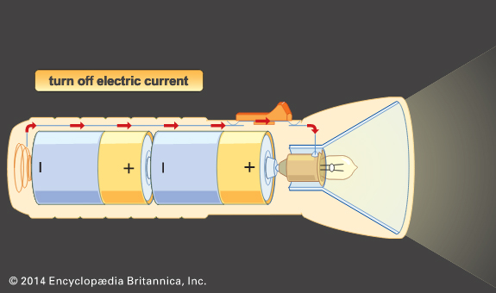 Sketch the schematic for the flashlight shown on the right.
2. Are the batteries in series or parallel?
3. Are they aiding or opposing?
4. If they are standard C batteries, how much voltage will be delivered to make this flashlight produce light?
5. On your sketch, indicate the direction of the current (conventional flow).
6. If one battery were reversed, would the flashlight operate? Explain.
7. Identify on the flashlight where the voltage potential is at zero volts?

# Problem Situation 2.2 – Designing a big flashlight

1. 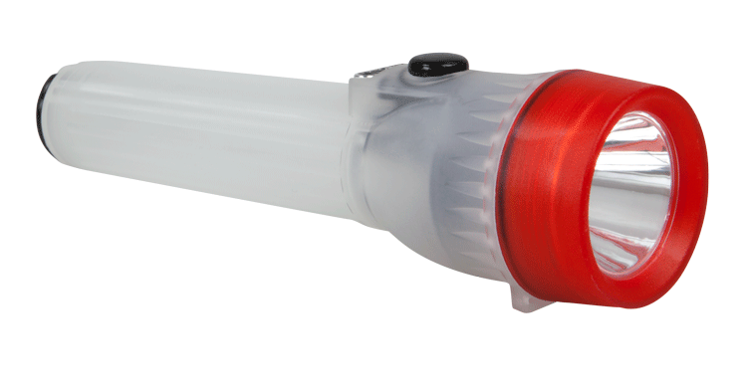You want a flashlight that produces a lot of light. The largest practical bulb requires 9 volts (max). How many D batteries would be required to provide the 9 Volts?
2. Should these batteries be in series or parallel? Would these batteries be aiding or opposing?
3. Sketch the schematic for this flashlight. On the schematic;
   1. label the positive and negative (+, -) terminals of the battery components
   2. indicate with an arrow the direction of the conventional current flow

# Problem Situation 2.3 – Door lock batteries

You acquired a battery-operated dead-bolt lock for your front door. It seems like a great solution for you. To move the deadbolt, it requires a significant amount of power. This lock requires 1.5 Volts at 2 Amps to move the deadbolt. A correct code opens a switch completing the circuit to withdraw the dead bolt.

1. How many AA batteries would be required to provide the 1.5 Volts at 2 Amps? AA batteries are rated at 2.85 amp hours and the maximum current each battery can produce is 0.600 A. Should these batteries be in series or parallel?
2. Sketch the schematic for this door lock. On the schematic;
   1. label the positive and negative (+, -) terminals of the battery components
   2. indicate with an arrow the direction of the conventional current flow

# 

# Problem Situation 2.4 – Ohm’s Law

We know that in a circuit there is a minimum of voltage, current and resistance. The following table defines the units.

|  |  |  |
| --- | --- | --- |
| **Quantity** | **Unit Name** | **Unit Symbol** |
| Electric current (I) | Ampere (amp) | A |
| Voltage (V) or | Volt | V, E |
| Electromotive force (E) |
| Resistance (R) | Ohm | Ω |
| Electric power (P) | Watt | W |

The German physicist *Georg Ohm* discovered and quantified the relationship between voltage, current and resistance in an electrical circuit.

**Ohm's law** states that the current through a conductor between two points is directly proportional to the voltage across the two points.

$Voltage=Current*Resistance$ (Quantities)

$Volts=Amperes*Ohms$ (Unit Names)

$V=IR$ (Unit Symbols)

By knowing any two values of the Voltage, Current or Resistance quantities we can use Ohms Law to find the third missing value. Ohms Law is foundational to most circuit analysis. Ohm’s triangle, shown below is a good memory tool.

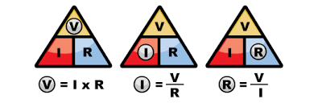

Ohm’s Law is a **linear** equation. A linear equation is an equation for a straight line when plotted on a graph. Each term is a first degree constant or variable.

1. Suppose you have a speaker that you want to install in your car. This 3Ω speaker draws power from the 12 V car battery. How much current will this speaker draw? Sketch the circuit.
2. Based on Ohm’s Law if you were to use a 5 V source with the same speaker, what would change and how much would it change?
3. For the following circuit; hold the resistance constant at 120 Ω; calculate the current as the voltage changes as indicated in the chart. Use no more than three significant digits.

|  |  |  |
| --- | --- | --- |
| **Voltage (V)** | **Current (mA)** | **Resistance (Ω)** |
| 10 |  | 120 |
| 20 |  | 120 |
| 30 |  | 120 |
| 40 |  | 120 |
| 50 |  | 120 |
| 60 |  | 120 |
| 70 |  | 120 |
| 80 |  | 120 |
| 90 |  | 120 |
| 100 |  | 120 |

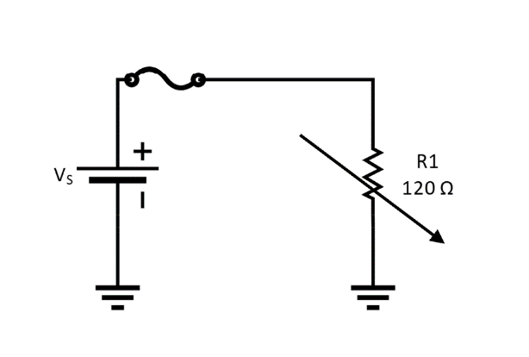

1. Graph the current and resistance on the following chart. Notice the axis units.
2. What is the shape of the graph? Can you recognize a relationship between voltage and current?
3. Looking at the graph, predict what the current would be if the voltage is 25 V and the resistance was the same at 120Ω. Then calculate the current, see how close your prediction was to the calculation, and verify that the graph is helpful.
4. Can you predict the voltage required if you changed the load to 80 Ω that required 1.2 Amps? What equation would you use? Can you calculate the voltage?
5. Can you label which each character depicts; Voltage in volts, Current in Amps and Resistance in Ohms.

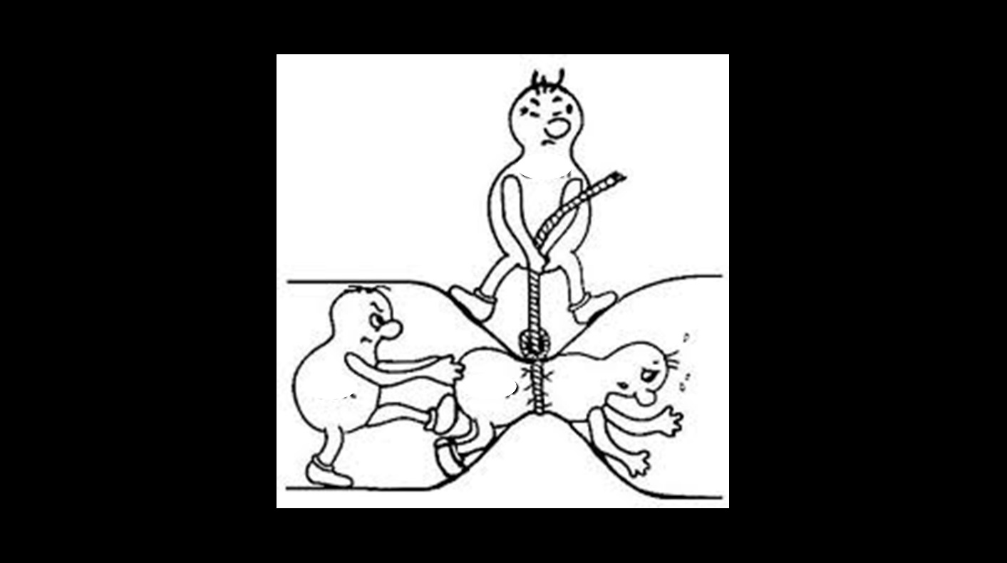

# Problem Situation 2.5 – Popcorn

1. Watch the following short clip. [Act 1 (https://youtu.be/BVh9Dt33bLQ).](https://youtu.be/BVh9Dt33bLQ)
2. What do you observe about this video?
3. Which configuration holds more popcorn?
4. [Act 3 (https://youtu.be/BVh9Dt33bLQ).](https://youtu.be/BVh9Dt33bLQ)

# Problem Situation 2.6 – Power Rule

Every electrical component consumes **power**. The letter P represents power in *Watts (W)*. Components such as a resistor convert electrical energy into heat. Electrical components are physically limited to the amount of power they can consume without burning up. Overloading electrical components destroys the components and can cause fires.

Power Rule

$Power=Current*Voltage$ (Quantities)

$Watts=Amperes*Volts$ (Unit Names)

$P=IV$ (Unit Symbols)

1. What equation would you use if you wanted to calculate the current and knew the power and the voltage?
2. What equation would you use if you wanted to calculate the voltage and had the power and the current?
3. In the following circuit, the load has a resistance of 300Ω and can handle 1/4 Watt of power without sustaining damage.
   1. What current does the load draw?



* 1. Will this component fail? First, take a guess and then calculate.
  2. What would you recommend changing about this circuit or components?

1. 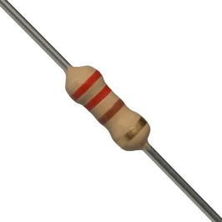A ¼ Watt 220 Ω resistor has 7.35 V measured across it. Will this resistor burn up? First, take a guess and then calculate the answer.
2. This same resistor used in the previous question has 10.3 mA through it. Can you predict the voltage potential across the resistor and the power consumed? Take a guess and then calculate the answer.
3. The following chart lists some common household appliances and devices. You need to determine the missing information.

|  |  |  |  |  |
| --- | --- | --- | --- | --- |
| **Device** | **Voltage (V)** | **Resistance**  **(Ω)** | **Current**  **(A)** | **Power**  **(W)** |
| Refrigerator | 120 |  |  | 1200 |
| Heater | 120 | 9.6 |  |  |
| TV | 120 |  | 2.5 |  |
| Hair Dryer | 120 | 9 |  |  |
| Phone Charger | 120 |  |  | 15 |
| Light bulb | 120 |  | 1 |  |