**Prerequisite Assumptions**

Before beginning the lesson, students should understand;

* Circuit modeling for DC serial and parallel resistive circuits
* Series and Parallel connected voltage sources,
* Application of Ohm’ Law,
* Application of the Power Rule,
* How to manipulate and solve a linear equation.

**COURSE COMPETENCIES**

1. Solve linear equations with one unknown

* You solve linear equations for one dependent variable
* You manipulate linear equations to isolate selected variables.
* You translate real problems into mathematical equations.
* You apply the mathematics to determine the components, quantities, and properties of DC resistive electrical circuits.
* Calculate power in DC resistive circuits
* Analyze series DC resistive circuits
* Analyze parallel DC resistive circuits
* Analyze parallel/series DC resistive circuits

**BACKGROUND**

This lesson applies linear equations to predict the behavior of electronic components when voltage is applied.

**EXPLICIT CONNECTIONS**

It is important that each person understands how to manipulate linear equations. The students should be fluent in applying Ohm’s law and the Power rule.

**NOTES TO SELF**

* Encourage each individual to accurately sketch the circuits.
* Have groups sketch and defend their circuit diagrams on the white board.
* Strongly encourage students to make predictions so they continue to build their confidence.

|  |  |  |
| --- | --- | --- |
| **Duration Minutes** | **Lesson** | **Suggested Structure** |
| 15 | Lecture: Linear Equations | Cohort |
| 20 | Problem Set 3.1: Linear Equations | Group |
| 10 | Blackboard: Practice Set 1 - Linear Equations | Individual |
| 20 | Lecture: Ohm's Wheel / DC Circuit Analysis | Cohort |
| 20 | Problem Set 3.2: DC Circuit Series | Group |
| 10 | Lecture: DC Series Resistors | Cohort |
| 15 | Blackboard: Practice Set 2 - DC Series Resistors | Individual |
| 20 | Lecture: DC Parallel Resistors | Cohort |
| 20 | Problem Set 3.3: DC Parallel Resistors | Group |
| 20 | Blackboard: Practice Set 3 - DC Parallel Resistors | Individual |
| 20 | Problem Set 3.4: Combined DC Parallel and Series Resistors | Group |
| 20 | Lecture: Power Rule and Manipulating Linear Equations | Cohort |
| 15 | Blackboard: Practice Set 4 - DC Circuit Analysis | Individual |
| 20 | Problem Set 3.5: DC Circuit Analysis | Group |
| 20 | Blackboard: Practice Set 5 - Applied Linear Equations | Individual |
| 20 | Quiz | Cohort |

|  |  |  |
| --- | --- | --- |
| ***Lesson*** | ***Objectives*** | ***Material*** |
| 3.1 | Creating a linear equation | Linear Equations |
| 3.2 | DC Circuits: Series Resistors | A birthday card |
| 3.3 | DC Parallel Resistors | A valentine card |
| 3.4 | Combined DC Parallel and Series Resistors | Circuit Analysis |
| 3.5 | Combined DC Parallel and Series Resistors | A new and improved card |

**Prerequisite Assumptions**

Before beginning the lesson, students should understand;

* Circuit modeling of resistive DC circuits,
* Series and Parallel connected voltage sources,
* Application of Ohm’ Law,
* Application of the Power Rule,
* How to manipulate and solve a linear equation.

**Specific Objectives**

*By the end of this lesson, you should understand;*

* Components and structure of an ideal circuit model
* Circuit Equivalency (Simplification / Reduction)
* How to mathematically determine equivalent resistance of series and parallel connected resistors
* Circuit analysis using Ohm’s Law and the Power Rule

*By the end of this lesson, you should be able to;*

* Apply Ohm’s Law and the Power Rule to analyze circuits
* Develop an equivalent model for a simple DC circuit
* Calculate the equivalent resistance for series and parallel connected resistors

**Problem Situation 3. 1 – Linear Equations**

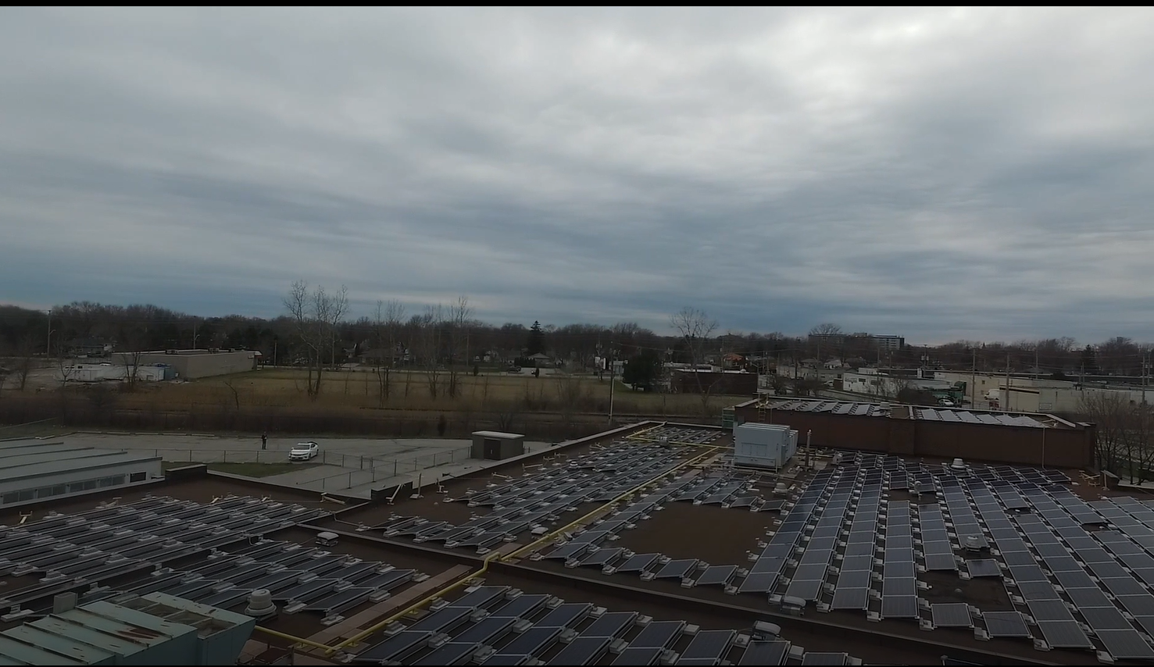

1. What are your observations? What information would you need to determine how much CO2 can be offset by this solar installation?

|  |
| --- |
| There are 582 panels. Five panels generate enough power to offset the CO2 gas produced by 4,848 km driven by the average passenger vehicles. |

1. How much CO2 gas emissions can these panels offset?

|  |
| --- |
| I need to find the total amount of CO2 gas offset by all the solar panels. $$\frac{582 solar panels}{Roof top installation}*\frac{4,848 kg}{5 solar panels}=564,307 kg$$ |

1. Write the linear equation used to determine the CO2 gas emissions these panels offset.

|  |
| --- |
| I need to write the linear equation for any number of panels. A linear equation has one dependent variable and one independent variable.  I will set my variables: p = panels and N = kg. $N=p\left(\frac{4,848 kg}{5 solar panels}\right)$ |

1. What do you need to know to determine how many homes the solar panel modules can power?

|  |
| --- |
| One home uses 9,000 kWh per year.  Four panels produce 1576 kWh per year. |

1. Determine how many homes all 582 solar panel modules can power.

|  |
| --- |
| $$\frac{582 solar panels}{Roof top installation}*\frac{1,576 kWh}{4 solar panels}*\frac{1 home}{9,000 kWh}$$ $$=25.5 homes can be powered by this rooftop installation$$ |

1. Write the linear equation used to determine the number of homes above.

|  |
| --- |
| I need to write the linear equation for any number of homes for this 582 solar panel rooftop installation. A linear equation has one dependent variable and one independent variable.  I will set my variables: p = panels and H = homes. $H=p\left(\frac{1,576 }{4}\right)*\left(\frac{1}{9,000}\right)$ |

**Problem Situation 3.2 – Series Resistors**

Remember that a schematic is a recipe for a circuit, and we use these schematics for design and analysis. A good model is key to a mathematical prediction of the circuit behavior. A good picture speaks more than a thousand words. It is good practice to sketch the circuit you are analyzing before you start predicting outcomes or making calculations.

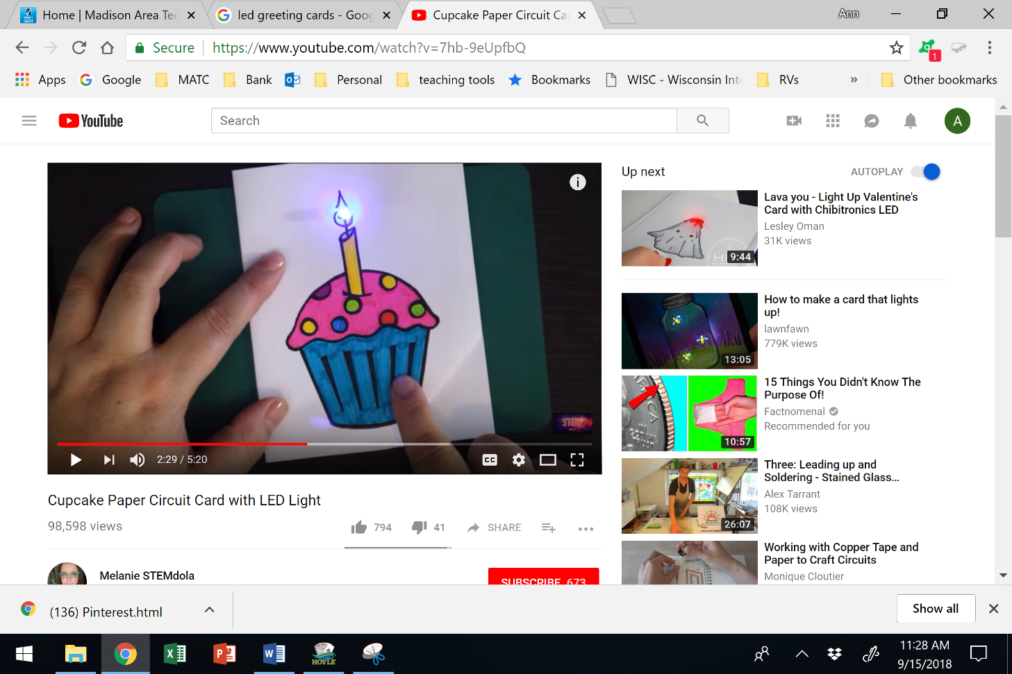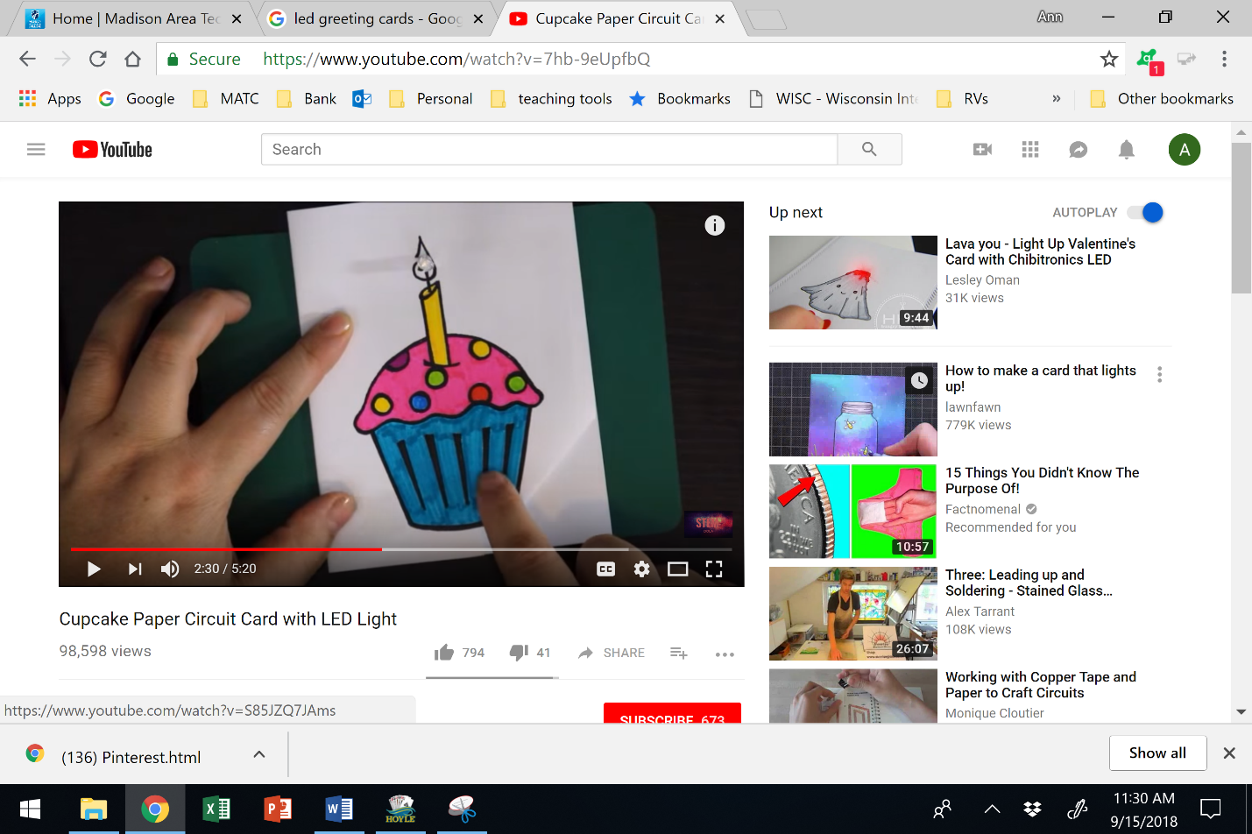

[Cupcake Paper Circuit Card with LED Light](http://www.youtube.com/watch?v=7hb-9eUpfbQ)

www.youtube.com/watch?v=7hb-9eUpfbQ

1. What do you need to know to design and sketch a circuit for this birthday card?

|  |
| --- |
| Resistance of an LED is dynamic, typically 50Ω - 160Ω. For the purpose of this problem assume 58Ω.  The voltage source is a button battery at 3V. The LED requires 2V – 4V. The LED is rated at 100mW. |

1. Sketch your design. *Remember to always indicate component polarities and current direction.*

|  |
| --- |
| Have each group sketch their circuit design on the whiteboard and explain their design. |

|  |
| --- |
| The circuit has to be able to provide at least 2 volts and since the battery is 3V I should be able to place the battery in series with the load.  When the switch is closed there should be 3V across the LED. |

1. Using your own design, calculate the current through the load?

|  |
| --- |
| I am being asked to find IL. I have VS and RL so I can use Ohm’s Law. $I_{T}=\frac{V_{S}}{R_{L}}=\frac{3.0V}{58Ω}=51.7 mA$ |

1. How much power is consumed by the load?

|  |
| --- |
| Ohm’s Wheel: to determine the power $P=IV=0.0517A*3V= \frac{V^{2}}{R}=\frac{{3V}^{2}}{58Ω}=I^{2}R={0.0517A}^{2}*58Ω=0.155W=155mW$ |

1. Can the LED consume this much power without damage? If not, what would you change in your design so that the power delivered to the load is under the rating for the LED?

|  |
| --- |
| Each group should talk about at least 2 ideas.  This LED will burn up. |

Resistors can be in a series configuration like the circuit below. Series resistors are connected daisy chain in a single line.

* Series resistors have the **same** current running through each one of them on the same conductive wire.
* Series resistors produce equivalent resistance that can be represented with a **single** resistor.

RTOTAL or RT represents the *equivalent* or *total* resistance of all the resistors in a circuit. For resistors in series; RT = R1 + R2 + R3….+ Rn

The circuit above would have an equivalent resistance of; RT = 100Ω + 200Ω + 300Ω = 600Ω

The equivalent circuit model is shown below.

Now the circuit is easier to analyze to find current.

The current is $I=\frac{V}{R_{T}}=\frac{36V}{600Ω}=0.06A=60mA$.

1. Use the following circuits to practice analyzing series resistance. Determine the requested information and sketch the minimized equivalent circuit



560 Ω

1.1 kΩ

6 V



|  |  |  |
| --- | --- | --- |
| RT = | |  |
| IT = | |  |
| VR1 = | |  |
| VR2 = | |  |
| PR1 = | |  |
| PR2 = | |  |
| PT = | |  |
| RT = | |  | | |
| IT = | |  | | |
| VR1 = | |  | | |
| VR2 = | |  | | |
| VR3 = | |  | | |
| VR4 = | |  | | |
| PT = | |  | | |

Sketch the equivalent circuit: Sketch the equivalent circuit:

|  |  |
| --- | --- |
|  |  |

1. Is the total resistance larger than the largest single resistor or smaller than the smallest resistor? Is this what you would have expected?

|  |
| --- |
| It is important that each student understands that series resistances sum together. |

1. Predict whether the voltage source equal the sum of the voltage drops across each resistor. Can you calculate this to see if it is true or false? Yes.

**Problem Situation 3.3 – Parallel Resistors**

[](https://manufacturingstories.com/wp-content/uploads/2018/01/Valentines-GIF.gif)

1. Using information from the cupcake card, what do you need to know to design and sketch a circuit for this Valentine’s Day card?

|  |
| --- |
| Resistance of an LED is dynamic, typically 50Ω - 160Ω. For the purpose of this problem assume 58Ω.  The voltage source is a button battery at 3V. The LED requires 2V – 4V. The LED is rated at 100mW. |

1. Sketch your design. *Remember to always indicate component polarities and current direction.*

|  |
| --- |
|  |

1. How many loads are there? Calculate the current through the loads.

|  |
| --- |
| There are three parallel loads. I need to find the current through each LED. I know the resistance of the load and the voltage across each LED. Since each load is the same each load will draw the same current. $$I_{R1}=I_{R2}=I_{R3}=\frac{V_{Load}}{R_{Load}}=\frac{3 V}{58 Ω}=51.7 mA$$ |

1. How much power does each of the loads consume? Do you expect it to be the same for each load?

|  |
| --- |
| I am asked to find the power consumed by each LED. This will validate that the components will operate within the component design parameters. $$P= \frac{V^{2}}{R}=\frac{3^{2}}{58 Ω}=155.2 mW$$ |

1. How much total power is consumed by the circuit?

|  |
| --- |
| I am asked to find the power consumed by all three LED. I am going to add these together. $$P= 3*155.2 mW=466 mW$$ |

1. Considering your own design, how much resistance does the voltage source see?

|  |
| --- |
| I need to find the total resistance. I know the voltage and the power and using Ohm’s Wheel I know $$P=\frac{V^{2}}{R}→R= \frac{3 V}{0.466 W}=19.3 Ω$$ |



This configuration for resistors is parallel.

* Resistors are connected in parallel when **each** end terminal of the resistors are connected or shared.
* Parallel resistors produce a resistance **smaller** than the **smallest** resistor.

RT represents the sum total of all the parallel resistances in a circuit.

$\frac{1}{R_{T}}=\frac{1}{R_{1}}+\frac{1}{R_{2}}+\frac{1}{R_{3}}…+\frac{1}{R_{n}}$

Example: Determine the total resistance of the circuit above, sketch the equivalent circuit and determine the total current that leaves the voltage source.



$\frac{1}{R_{T}}=\frac{1}{90}+\frac{1}{200}+\frac{1}{1000}$

Calculator: (90-1 +200-1 + 1000-1)-1 = 58.4Ω

Using Ohm’s Law: $I_{T}=\frac{V}{R}=\frac{36V}{58.4Ω}=0.616A=616mA$

1. Use the following circuits to practice analyzing parallel resistance. Determine the requested information and sketch the minimized circuits.



|  |  |
| --- | --- |
| RT = |  |
| IT = |  |
| IR1 = |  |
| IR2 = |  |
| PR1 = |  |
| PR2 = |  |
| PT = |  |



|  |  |
| --- | --- |
| RT = |  |
| IT = |  |
| IR1 = |  |
| IR2 = |  |
| IR3 = |  |
| PT = |  |



1. Is the total resistance larger than the largest single resistor or smaller than the smallest resistor? Is this what you would have expected?

|  |
| --- |
| Smaller. Yes.  This is an important concept so discussion with the cohort is important. |

1. Does the total current equal the sum of the currents through each resistor?

|  |
| --- |
| Yes. |

**Problem Situation 3.4 – Series and Parallel Resistors**

1. Circuits typically have both series and parallel resistors. For the circuit below identify the following.



* 1. a node
  2. a branch
  3. series resistors
  4. parallel resistors

1. How would you start an analysis of this circuit?

|  |
| --- |
| By looking for the series connected and parallel connected resistors. |

1. Analyze the circuits to determine the following. Sketch the minimized equivalent circuit.



|  |  |
| --- | --- |
| RT = | 94.3 Ω |
| IT = | 106 mA |
| PT = | 1.06 W |

|  |
| --- |
|  |

|  |  |
| --- | --- |
| RT = | 135 Ω |
| IT = | 89.1 mA |
| PT = | 1.07 W |



47Ω

90Ω

3.3 kΩ

|  |
| --- |
| $$R_{T}=R_{1}+\left(R_{2}∥R_{3}\right)$$ $$I_{T}=\frac{V_{S}}{R_{T}}$$ $$P=IV$$ |

1. Determine the value for the missing component in the following circuits.

RT = 370Ω



8 kΩ

2.2 kΩ

233 mA

12 V

120Ω

|  |
| --- |
| Using Ohm’s Wheel    R1 = __90 Ω________________ R3 = ___470 Ω__________ |

**Problem Situation 3.5 – A better Valentine’s Day Card.**

[](https://manufacturingstories.com/wp-content/uploads/2018/01/Valentines-GIF.gif)

1. Revisiting your design for this circuit, below is the data sheet for the LEDs and the battery available to you.

*LED datasheet*

Current - (25 - 30 mA)

Voltage: (4.2 - 5 V)

Power Maximum: 125 mW

*Battery:* 2032 Button Batteries 3 volts each.

Measured resistance with voltage applied: 180 Ω

1. How many batteries may be required? What configuration of batteries would you use?

|  |
| --- |
| There should be 2 batteries but could be 3 depending on design. |

1. Would you place the LEDs in series or parallel? How would this affect your battery ‘design’?
2. Sketch your design. *Remember to indicate component polarities and current direction.*

|  |
| --- |
| The total resistance of the 3 LEDs in parallel is 60 Ω. If I target 4.5 V across each LED, then I would need at least 75 mA for all three LEDs.  The voltage drop across R1 must be 1.5 volts. So $R_{1}=\frac{1.5 V}{0.075 A}=20Ω$ |

1. Validate that your circuit meets the specifications of the LEDs.

|  |
| --- |
| I need to make sure that we do not exceed  Current - (25 - 30 mA) 25 mA per LED  Voltage: (4.2 - 5 V) 4.5 V per LED  Power Maximum: 125 mW 113 mW per LED |