|  |  |  |
| --- | --- | --- |
| ***Lesson*** | ***Objectives*** | ***Material*** |
| 3.1 | Creating a linear equation | Linear Equations |
| 3.2 | DC Circuits: Series Resistors | A birthday card |
| 3.3 | DC Parallel Resistors | A valentine card |
| 3.4 | Combined DC Parallel and Series Resistors | Circuit Analysis |
| 3.5 | Combined DC Parallel and Series Resistors | A new and improved card |

**Prerequisite Assumptions**

Before beginning the lesson, students should understand;

* Circuit modeling of resistive DC circuits,
* Series and Parallel connected voltage sources,
* Application of Ohm’ Law,
* Application of the Power Rule,
* How to manipulate and solve a linear equation.

**Specific Objectives**

*By the end of this lesson, you should understand;*

* Components and structure of an ideal circuit model
* Circuit Equivalency (Simplification / Reduction)
* How to mathematically determine equivalent resistance of series and parallel connected resistors
* Circuit analysis using Ohm’s Law and the Power Rule

*By the end of this lesson, you should be able to;*

* Apply Ohm’s Law and the Power Rule to analyze circuits
* Develop an equivalent model for a simple DC circuit
* Calculate the equivalent resistance for series and parallel connected resistors

**Problem Situation 3. 1 – Linear Equations**



1. What are your observations? What do you wonder?
2. How much CO2 gas emissions can these panels offset?
3. Write the linear equation used to determine the CO2 gas emissions these panels offset.
4. What do you need to know to determine how many homes the solar panel modules can power?
5. Determine how many homes all 582 solar panel modules can power.
6. Write the linear equation used to determine the number of homes above.

**Problem Situation 3.2 – Series Resistors**

Remember that a schematic is a recipe for a circuit, and we use these schematics for design and analysis. A good model is key to a mathematical prediction of the circuit behavior. A good picture speaks more than a thousand words. It is good practice to sketch the circuit you are analyzing before you start predicting outcomes or making calculations.

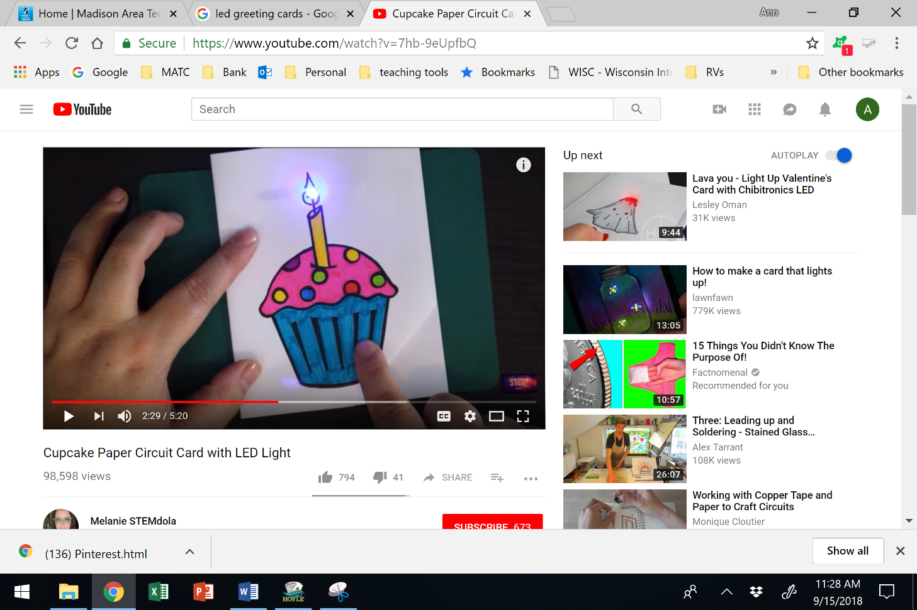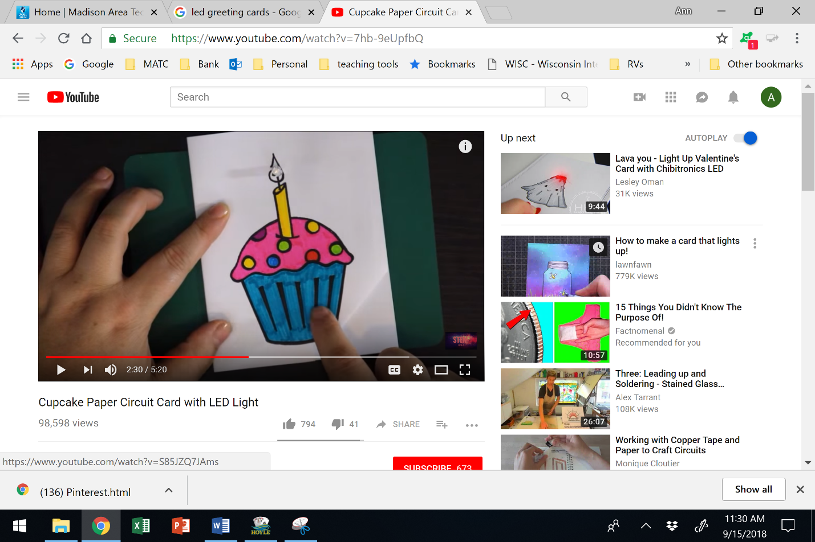

[Cupcake Paper Circuit Card with LED Light](http://www.youtube.com/watch?v=7hb-9eUpfbQ)

www.youtube.com/watch?v=7hb-9eUpfbQ

1. What do you need to know to design and sketch a circuit for this birthday card?
2. Sketch your design. *Remember to always indicate component polarities and current direction.*
3. Using your own design, calculate the current through the load?
4. How much power is consumed by the load?
5. Can the LED consume this much power without damage? If not, what would you change in your design so that the power delivered to the load is under the rating for the LED?

Resistors can be in a series configuration like the circuit below. Series resistors are connected daisy chain in a single line.

* Series resistors have the **same** current running through each one of them on the same conductive wire.
* Series resistors produce equivalent resistance that can be represented with a **single** resistor.

RTOTAL or RT represents the *equivalent* or *total* resistance of all the resistors in a circuit. For resistors in series; RT = R1 + R2 + R3….+ Rn

The circuit above would have an equivalent resistance of; RT = 100Ω + 200Ω + 300Ω = 600Ω

The equivalent circuit model is shown below.

Now the circuit is easier to analyze to find current.

The current is $I=\frac{V}{R_{T}}=\frac{36V}{600Ω}=0.06A=60mA$.

1. Use the following circuits to practice analyzing series resistance. Determine the requested information and sketch the minimized equivalent circuit



560 Ω

1.1 kΩ

6 V



|  |  |
| --- | --- |
| RT = |  |
| IT = |  |
| VR1 = |  |
| VR2 = |  |
| PR1 = |  |
| PR2 = |  |
| PT = |  |

|  |  |
| --- | --- |
| RT = |  |
| IT = |  |
| VR1 = |  |
| VR2 = |  |
| VR3 = |  |
| VR4 = |  |
| PT = |  |

Sketch the equivalent circuit: Sketch the equivalent circuit:

1. Is the total resistance larger than the largest single resistor or smaller than the smallest resistor? Is this what you would have expected?
2. Predict whether the voltage source equal the sum of the voltage drops across each resistor. Can you calculate this to see if it is true or false?

**Problem Situation 3.3 – Parallel Resistors**

[](https://manufacturingstories.com/wp-content/uploads/2018/01/Valentines-GIF.gif)

1. Using information from the cupcake card, what do you need to know to design and sketch a circuit for this Valentine’s Day card?
2. Sketch your design. *Remember to always indicate component polarities and current direction.*
3. How many loads are there? Calculate the current through the loads.
4. How much power does each of the loads consume? Do you expect it to be the same for each load?
5. How much total power is consumed by the circuit?
6. Considering your own design, how much resistance does the voltage source see?



This configuration for resistors is parallel.

* Resistors are connected in parallel when **each** end terminal of the resistors are connected or shared.
* Parallel resistors produce a resistance **smaller** than the **smallest** resistor.

RT represents the sum total of all the parallel resistances in a circuit.

$\frac{1}{R_{T}}=\frac{1}{R_{1}}+\frac{1}{R_{2}}+\frac{1}{R_{3}}…+\frac{1}{R_{n}}$

***Example***: Determine the total resistance of the following circuit, sketch the equivalent circuit, and determine the total current that leaves the voltage source.



$\frac{1}{R_{T}}=\frac{1}{90}+\frac{1}{200}+\frac{1}{1000}$

Calculator: (90-1 +200-1 + 1000-1)-1 = 58.4Ω

Using Ohm’s Law: $I_{T}=\frac{V}{R}=\frac{36V}{58.4Ω}=0.616A=616mA$

1. Use the following circuits to practice analyzing parallel resistance. Determine the requested information and sketch the minimized circuits.



|  |  |
| --- | --- |
| RT = |  |
| IT = |  |
| IR1 = |  |
| IR2 = |  |
| PR1 = |  |
| PR2 = |  |
| PT = |  |



|  |  |
| --- | --- |
| RT = |  |
| IT = |  |
| IR1 = |  |
| IR2 = |  |
| IR3 = |  |
| PT = |  |

1. Is the total resistance larger than the largest single resistor or smaller than the smallest resistor? Is this what you would have expected?
2. Does the total current equal the sum of the currents through each resistor?

**Problem Situation 3.4 – Series and Parallel Resistors**

1. Circuits typically have both series and parallel resistors. For the circuit below identify the following.



* 1. a node
  2. a branch
  3. series resistors
  4. parallel resistors

1. How would you start an analysis of this circuit?
2. Analyze the circuits to determine the following. Sketch the minimized equivalent circuit.

|  |  |
| --- | --- |
| RT = |  |
| IT = |  |
| PT = |  |



|  |  |
| --- | --- |
| RT = |  |
| IT = |  |
| PT = |  |



47Ω

90Ω

3.3 kΩ

1. Determine the value for the missing component in the following circuits.

RT = 370Ω



8 kΩ

2.2 kΩ

233 mA

12 V

120Ω

R1 = _____________________ R3 = ____________________

**Problem Situation 3.5 – A better Valentine’s Day Card.**

[](https://manufacturingstories.com/wp-content/uploads/2018/01/Valentines-GIF.gif)

1. Revisiting your design for this circuit, below is the data sheet for the LEDs and the battery available to you.

*LED datasheet*

Current - (25 - 30 mA)

Voltage: (4.2 - 5 V)

Power Maximum: 125 mW

*Battery:* 2032 Button Batteries 3 volts each.

Measured resistance with voltage applied: 180 Ω

1. How many batteries will be required? What configuration of batteries would you use?

1. Would you place the LEDs in series or parallel? How would this affect your battery ‘design’?
2. Sketch your design. *Remember to indicate component polarities and current direction.*
3. Validate that your circuit meets the specifications of the LEDs.